User Guide Microsoft Word

(Links & Comments, Header & Footer, Text, and Symbols)

Release 1.0

Microsoft Word User Guide (Links & Comments, Header & Footer, Text, and Symbols) Release 1.0

Copyright © 2020, 2021, Microsoft Word / or its affiliates. All right reserved

Primary Author: Kavitha Sree

The software and related documentation are provided under a license agreement containing restrictions on use and disclosure and are protected by intellectual property laws. Except as expressly permitted in your license agreement or allowed by law, you may not use, copy, reproduce, translate, broadcast, modify, license, transmit, distribute, exhibit, perform, publish, or display any part, in any form, or by any means. Reverse engineering, disassembly, or decompilation of this software, uselessly required by law for interoperability, is prohibited.

The information contained herein is subject to change without notice and is not warranted to be error-free. If you find any errors, please report them to us in writing.

Preface

Microsoft Word User Guide offers an introduction to using Microsoft Word Applications from an end user's perspective. It explains how to use the features in the Insert Tab.

Microsoft Word User Guide is for the end user's perspective, who is willing to learn and explore the Microsoft Word Application.

1. Document Accessibility

For the information and use the Microsoft Word Application

Download the latest version

<https://www.microsoft.com/en-in/microsoft-365/word>

**BLANK PAGE**

Contents

Preface iii

Document Accessibility iii

Contents v

1. INTRODUCTION 1-1
2. LINKS & COMMENTS 2-1

Links 2-1

Comments 2-4

1. HEADER & FOOTER 3-1

Inserting Header & Footer 3-1

Creating Different Sections in Header and Footer 3-4

Different Header and Footer 3-5

Different Odd & Even pages in Header/Footer 3-8

1. TEXT AND SYMBOLS 4-1

Text Box 4-1

Quick Parts 4-2

Word Art 4-3

Drop Cap 4-3

Signature Line - Date &Time - Object 4-4

1. SYMBOLS 5-1

Equation 5-1

Symbol 5-2

INDEX i

**BLANK PAGE**

INTRODUCTION

Microsoft word is the processor that helps to create a document, letters, and reports. These can appear as professional quality documents used on different platforms. In this approach of Ms word documentation, we have many features to design the word document in a predominant structure.

Each feature has its standard and utility, by which documents attain a structure.

In Microsoft word, we mainly discuss a few features like Links and Comments, Header & Footer, Text, and symbols.

These features are in the Insert menu tab.

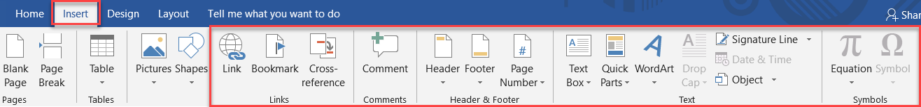

Figure ‑ Insert Task Bar

**BLANK PAGE**

LINKS & COMMENTS

1. Links

Links are used in specifying the location within the document or the web pages. Allow the information to users without repeating the same on different pages.

Table ‑ List of Links and their usage

| LINKS | USAGE |
| --- | --- |
|  | It is used to create a hyperlink to the existing files in the computer and specify the document's location for external reference. |
|  | Mark a place in the document for easy identification.  It is just like placing a bookmark in a book |
|  | Refer to a specific page in the document such as heading, figures, and tables |

To create a Hyperlink:

* 1. On the Insert menu, Click the option, and a dialogue box opens
     1. Choose the option required in Link to.
     2. Look in for the file which has to be linked.
     3. Give the linked filename in Text to display
     4. Click ok.

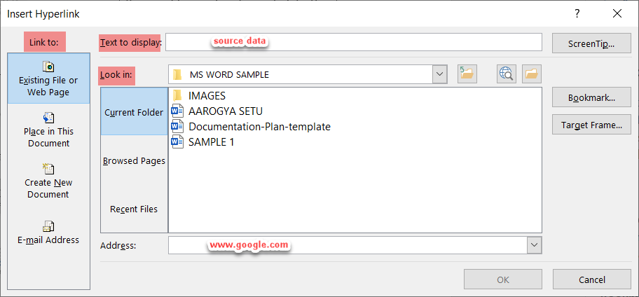

Figure ‑ Insert Hyperlink

Remove Hyperlink

* 1. To remove the Hyperlink, right-click on the Link.
     1. Go to Remove Hyperlink from the drop-down list.

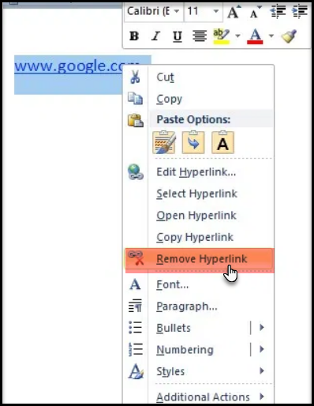

Figure ‑ Remove Hyperlink

To create a Bookmark and Cross-reference

* 1. Select any word from the document to provide a Bookmark,
  2. Click the 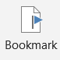 option.
     1. Write a text name (selected word) in the Bookmark name.
     2. Click Add.

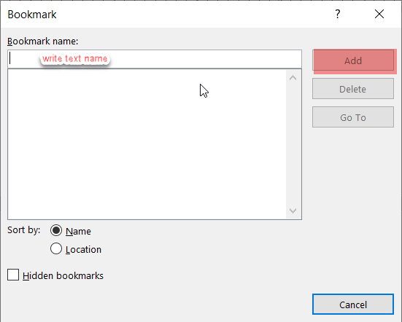

Figure ‑ Creating a Bookmark

* 1. Place the cursor in the location for the Bookmark to set.
  2. Select 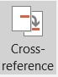 from the Insert Menu, and a dialogue box pops up.
     1. Now select the Reference type as Bookmark.
     2. Click to select the drop-down, For which Bookmark.
     3. Click on Insert.

To check, Ctrl and click the Link.

It will jump to the location where the Bookmark is set.

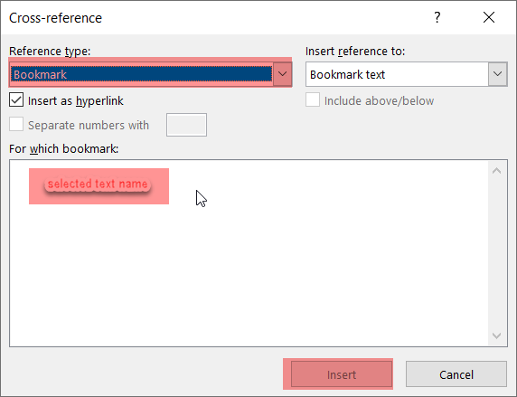

Figure ‑ Cross-reference to Created Bookmark

1. Comments

It is to give comments on the document. To provide a means for instructors to comment on the works.

* 1. Select a certain text to place a comment.
  2. Click the 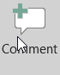, from the Insert Menu bar.
  3. Type a comment.
  4. Use the Esc key or click on the document text when finished.

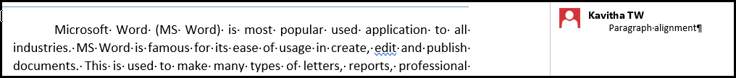

Figure ‑ Comments

HEADER & FOOTER

The Header is the top margin of each page, and Footer is the bottom margin. It is helpful to include the header and footer section material such as the document title and the page number.

1. Inserting Header & Footer
   1. Click on Insert and select the desired option.

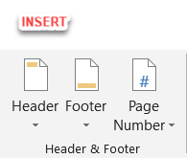

Figure ‑ Header & Footer

* 1. Click on either of the icons from the drop-down Menu of Header and Footer with several build-in options.

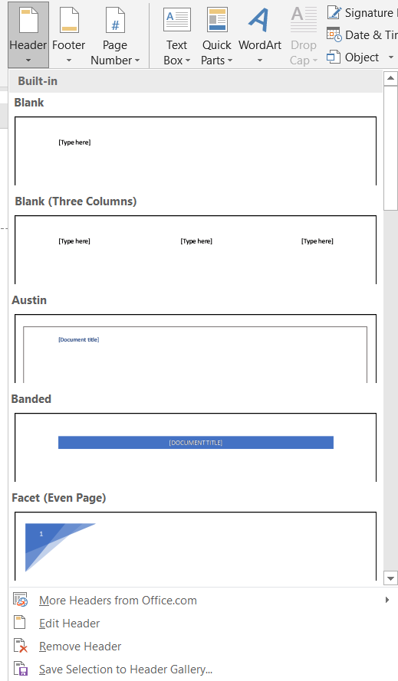 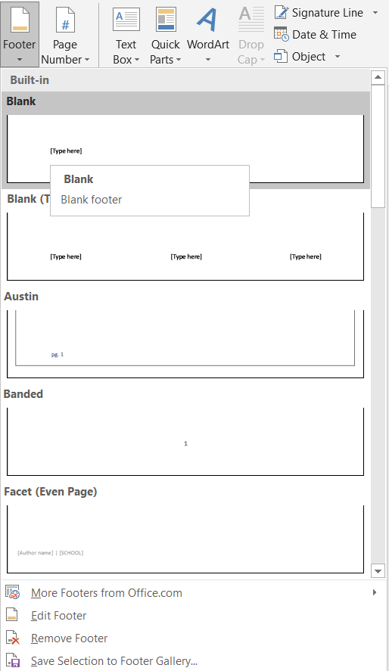

Figure ‑ Build-in options of Header & Footer

* 1. If you want to add the simple Header and Footer as the title or the document name, choose the first option from the built-in Header and Footer. It will bring the cursor into the Header (or Footer).
  2. A Contextual tab (Design tab) highlighted in the menu bar allows us to do the required changes in the Header (or Footer).

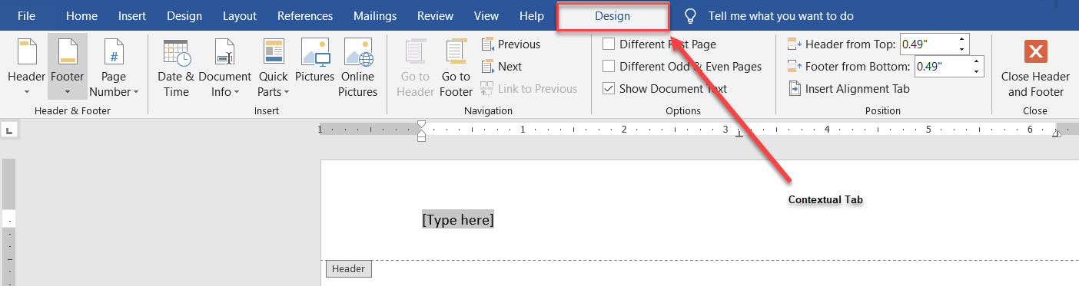

Figure ‑ Highlighted Contextual Tab

* 1. For instance, if you want to change the alignment of the Text given in the Header (or Footer), the user can go to the Home tab and select any alignment icon in the Paragraph group.

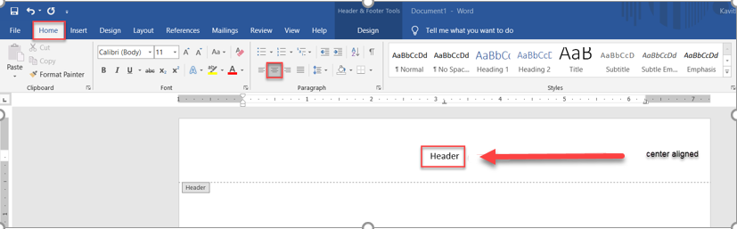

Figure ‑ Center-aligned Header

* 1. Here is a list of different page numbers given in the section. Click on it to select from the drop-down.

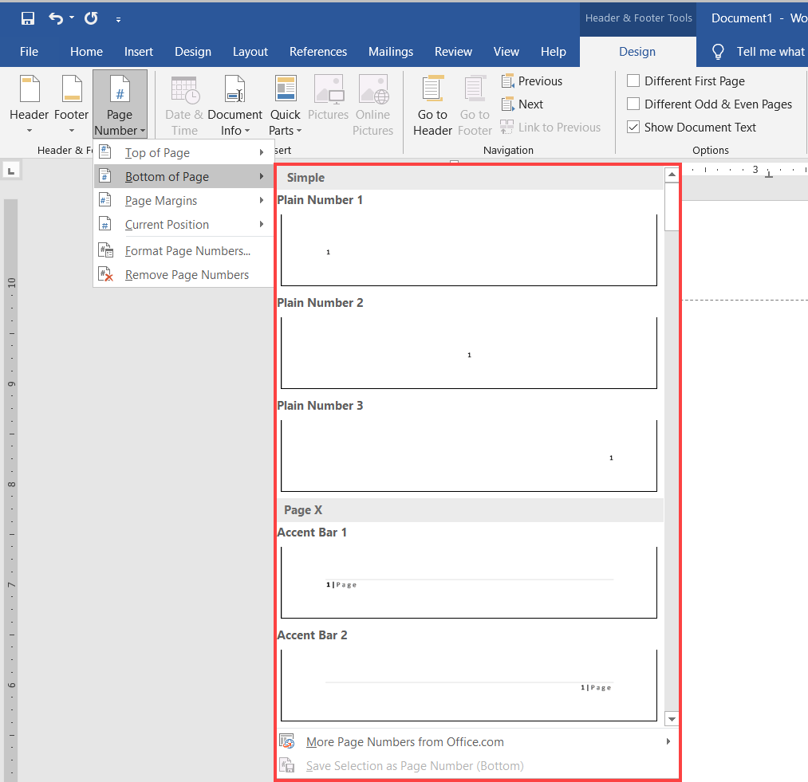

Figure ‑ Alignment of Page Number

1. Creating Different Sections in Header and Footer

The user needs to create section breaks in the document for different sections in the Header and Footer

* 1. Place the cursor where you want to have a section break.
  2. On Ribbon, select Layout tab → Breaks→ Section Breaks (Next page).

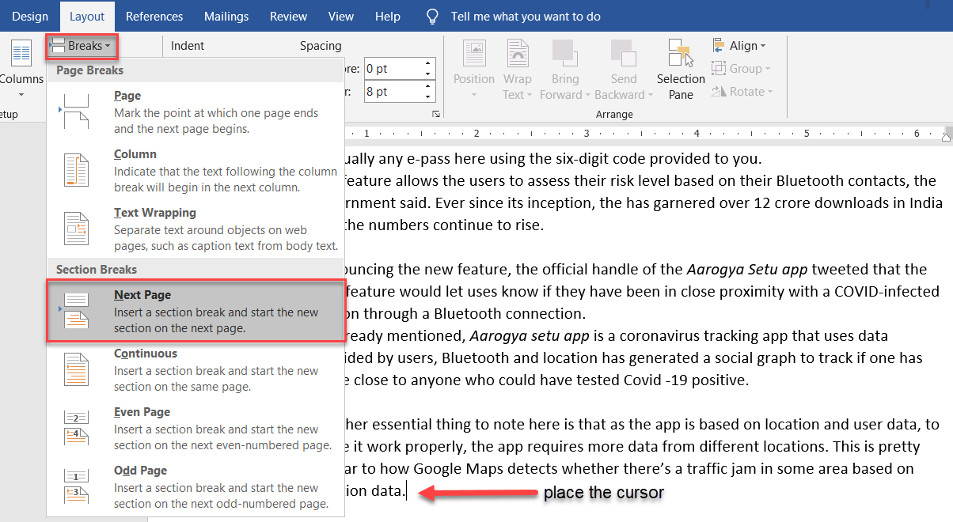

Figure ‑ Section Breaks to Define Sections

* 1. Review the section numbers by double-clicking on the header/footer.

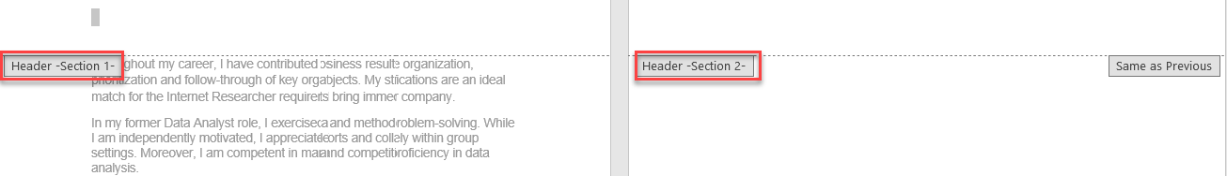

Figure ‑ Different Section Layout

* 1. After inserting the desired section breaks, select Link to Previous in the design tab depending upon the requirement. It allows different headers/footers in various sections.

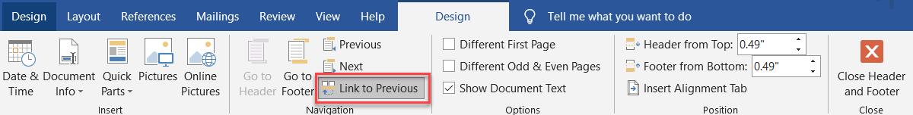

Figure ‑ Selection of Link to Previous

Different Header and Footer

To remove the Header from the first page

* 1. Double-click in the header area, and it shows up a design tab.
  2. Select the Different First Page checkbox.

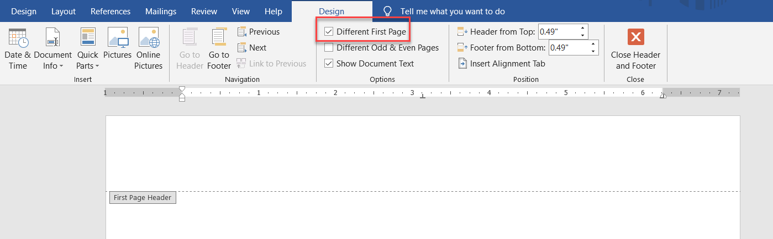

Figure ‑ Selection of Different First Page

It will remove the Header on the first page and preserve the Header on every other document page.

**Note**: No Header for a cover page or title page.

Creating a footer for the first page of the document

* 1. Always start the document from the first page (i.e. Right/odd page).
  2. Now create your styles for the document like chapter title, topic, sub-topic, and so on.
  3. Give page numbers as shown in Figure 3‑5 Alignment of Page Number
  4. To format the page numbers, Select page number → Right-click → Format page numbers.

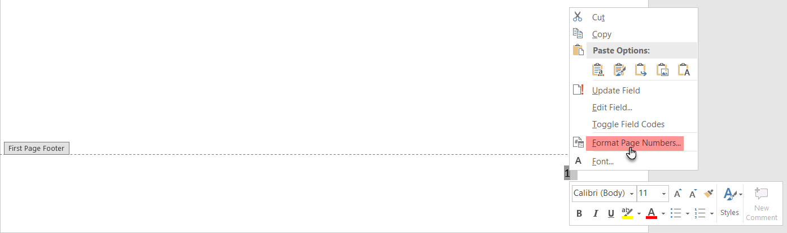

Figure ‑ Formatting Page Numbers

* 1. In the dialogue box, edit the page numbers as per requirement.

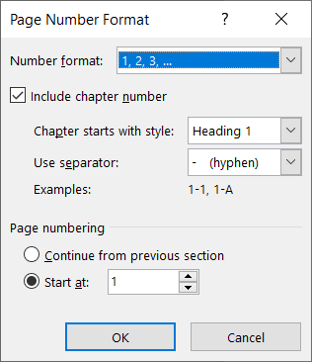

Figure ‑ Page Number Format

* 1. Now descriptive content before the page number.
  2. For this, keep the cursor at the Footer page number.

Go to Insert → Quicks parts → Field

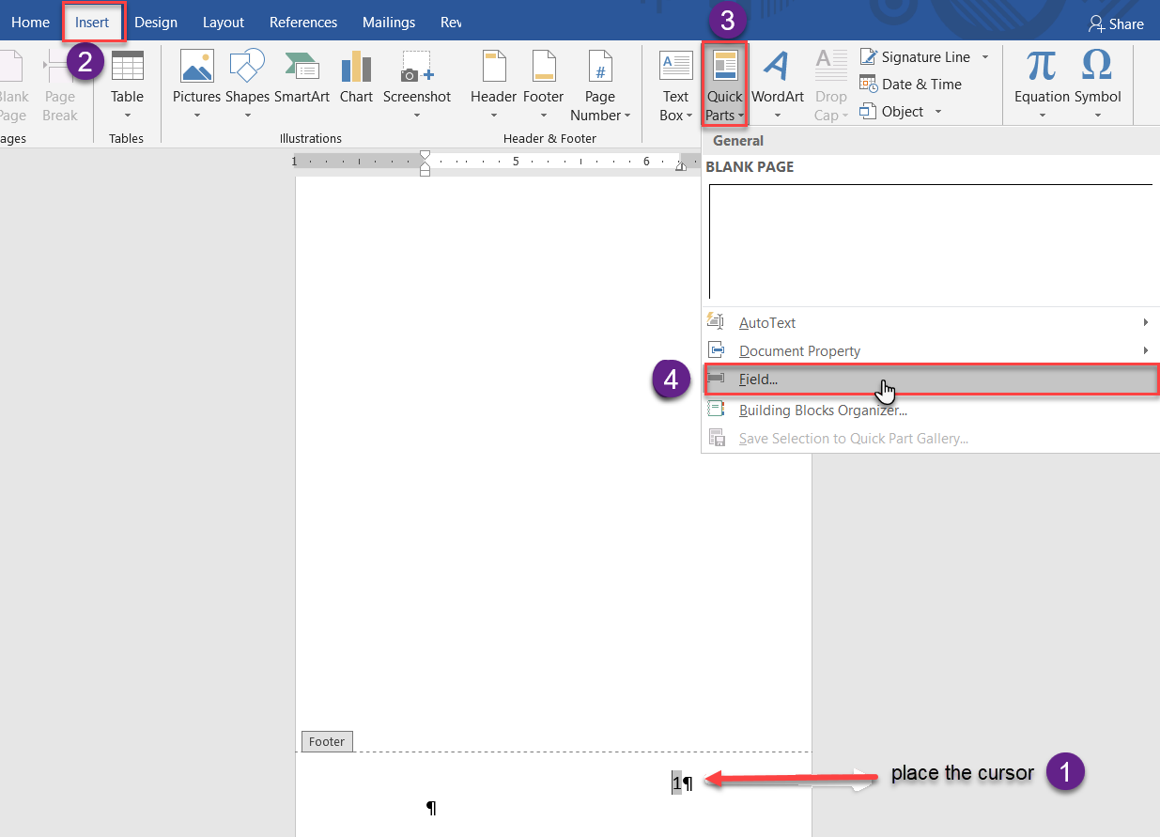

Figure ‑ Insertion of Descriptive in Header/Footer

* + 1. In the below dialogue box, Select the Field names as StyleRef.
    2. In the Field properties, choose a Style name as per your requirement (for example, chapter title).
    3. Click ok.

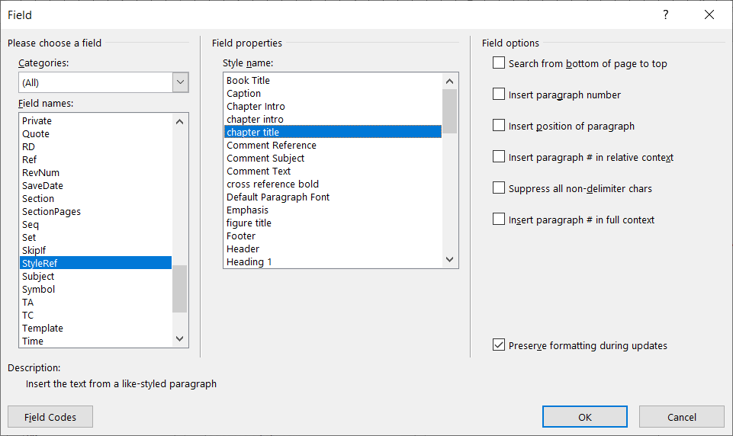

Figure ‑ Characteristics of Field

Now the chapter title created in the Footer section

When the chapter title in the document changes, the title in the footer section changes automatically.

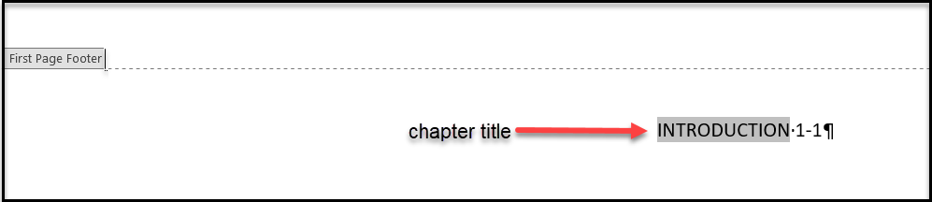

Figure ‑ Descriptive Content in Footer Section

1. Different Odd & Even pages in Header/Footer
   1. Double-click on the Header/Footer section, a design tab appears.
   2. Select Different Odd & Even pages checkbox.

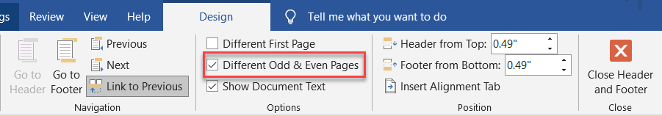

Figure ‑ Selection of Different First Page

* 1. Place the cursor at the required section as shown in Figure 3‑12 Insertion of Descriptive in Header/Footer & Figure 3‑13 Characteristics of Field
  2. Footer for Different Odd & Even pages, follow the steps as shown in Creating a footer for the first page of the document

Note: **Figure 3-13 Characteristics** **of Field** change the Style name as per the requirement.

**BLANK PAGE**

TEXT AND SYMBOLS

The Text features allow formatting text within them with various styles and effects.

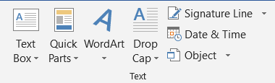

Figure ‑ Text

1. Text Box

The Text Box is used to write a piece of information at any place in the document. These are the default text boxes.

Choose from Build-in or Draw a Text Box.

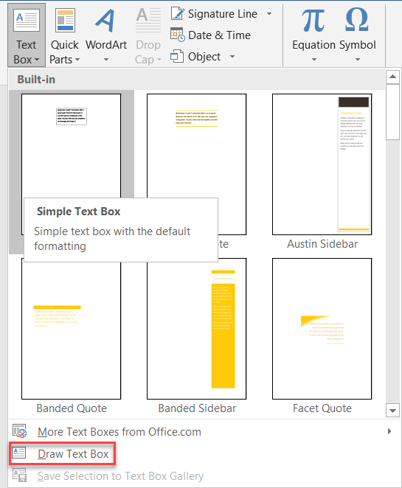

Figure ‑ Build-in Text Box

**BLANK PAGE**

1. Quick Parts

The Quick Parts are for easy accessibility to create, store and reuse the content.

How to add content to Quick Parts

* 1. Design content to reuse at different places in a document.
  2. Select the content.
  3. Insert → Quick Parts → Save Selection to Quick Part Gallery.

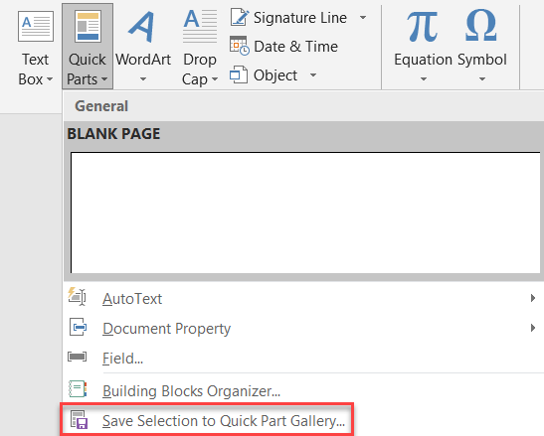

Figure ‑ Quick Part Gallery

* 1. Content added to the gallery of quick parts.

1. Word Art

It is a text box of various styles. The user can fill the text box with whatever type is required.

Insert → Word Art

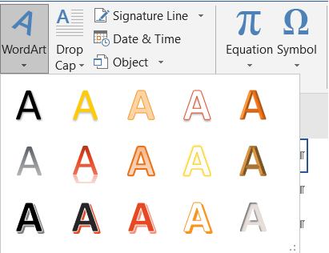

Figure ‑ Word Art

1. Drop Cap

To define a Large capital letter at the beginning of the paragraph. Users can align the Drop Cap as per the specifications.

Insert → Drop Cap

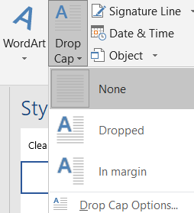

Figure ‑ Drop Cap

1. Signature Line - Date &Time - Object

Table ‑ List of Text Items

|  |  |
| --- | --- |
|  | It adds a visible representation of his or her signature to the document.  It's a handwritten input via graphics tablet or touches input on a PC |
|  | By just clicking on it, Date &Time appears.  Select the Update automatically checkbox. The date is inserted and will update automatically. |
|  | It is to link a document with a different application. For example, can embed an Excel spreadsheet within a document. |

SYMBOLS

1. Equation

An Equation is a Mathematical expression used in the document. In this Microsoft Word, there are inbuild equations such as the Area of a circle, the Binomial theorem, and many more.

The user can create their equations using mathematical symbols and structures present in the library.

Insert → Equation → Select the desired equation or Insert New Equation

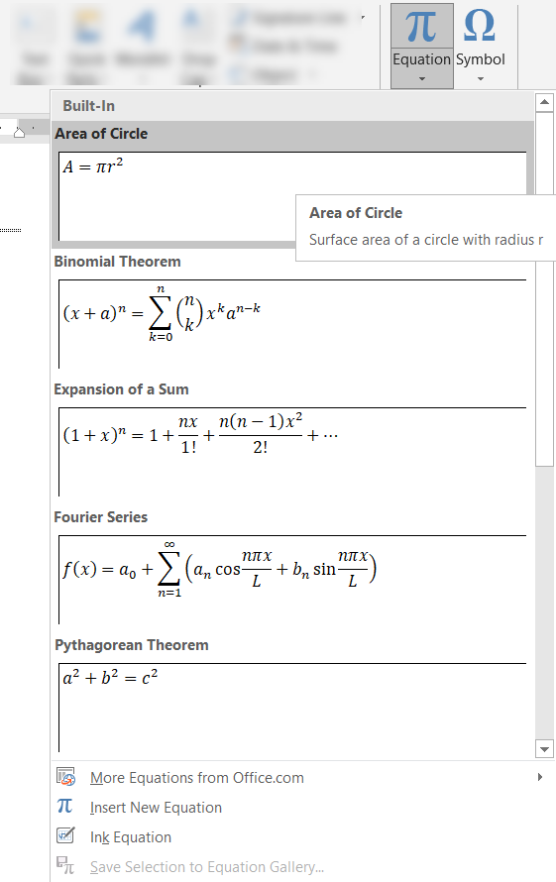

Figure ‑ Build-in Equation

1. Symbol

The document creation user may require a symbol or special character that does not appear on the keyboard.

List of symbols and special characters used within the Text and get inlined with the Text.

Insert → Symbol → More Symbols→ Select the required Symbols or Special Character → Click Insert

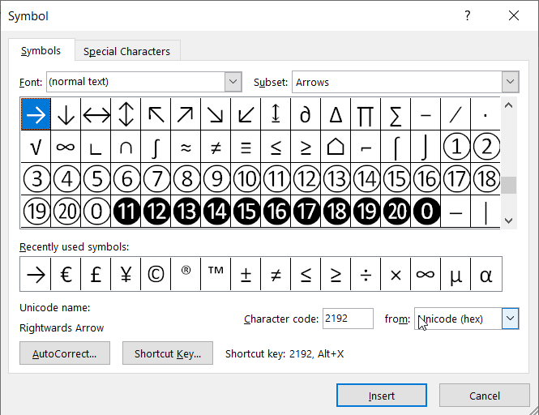

Figure ‑ Symbols and Special Characters

INDEX

A

accessibility, 4-2

C

comments, 2-4

content, 3-6, 4-2

D

descriptive, 3-6

document, 1-1, 2-1, 2-3, 2-4, 3-1, 3-2, 3-4, 3-5, 3-7, 3-8, 4-1, 4-2, 4-4, 5-1, 5-2

F

features, iii, 1-1, 4-1

I

information, 2, iii, 2-1, 4-1

L

location, 2-1, 2-3

S

simple Header, 3-2

specifications, 4-3